Climate Change to Dynastic Change

**Introduction**

Researchers have long tried to establish causal association between climate change and social conflict. A lot of studies have shown various causal pathways by which climatic variables can be linked to resource scarcity causing violence, armed conflict or war in decadal scale and even the collapse of civilization in centennial scale. Most societies across the continents are dependent on abundant agricultural production and we know from empirical research how climate change can negatively impact land fertility and bio-productivity and damage agricultural condition. Low standard of living due to lack of access to required resources can heighten resentment in the general populace and cause social unrest, chaos, political instability in a region. Gross domestic product (GDP) as an aggregate measure of production and per capita income and food supply per capita as a measure of individual economic condition and accessibility are generally used as critical index to reflect economic health of a region. Climatic variables like temperature, precipitation, monsoonal activity have correlation with GDP and income which are evidences of the negative effect of climate change in short or term. Modern complex societies, specially under a democratic regime, tend to have higher adaptation to the climatic change and social mechanism in place to tackle shortage and deficiency in resource and handle unrest or rebellions with military power. However, feudal, agro-based, less-educated and less-connected societies in pre-industrial eras were prone to suffer from harsh climate change and agriculturally unfavorable periods due to climatic influence were the times when civilizations have found to be collapsed. There are various studies showing how non-democratic, politically unstable societies can experience economic downfall, violence and social disturbance even in short period of time through climate influence. Most studies focus on local regions or a narrow timeline due to the unavailability of reliable high precision data on a global level. UN Secretary-General Ban Ki-moon (2007) has mentioned in his speech that ‘The Darfur conflict began as an ecological crisis, arising at least in part from climate change.’ President Climate change is definitely not the primary cause behind every social collapse and there are many other reasons behind civil conflict or nomadic conquests but climate change can still have influence on the intermediate variables in a lengthy causal link towards aggression, violence and the uproot of social orders. In our study, we have used a global civilization dataset which encompasses all the regions over last 2000 years to emphasize the claim that climate change directly or indirectly intrigue geo-political change.

Climate change due to lower rainfall, prolonged lower or higher temperature, intense cooling period via solar activity degrade the environment for agricultural production and may cause food, fresh water, energy insufficiency for the population. Adaptation to such change requires social stability, co-operative framework for advance preparatory resource storage for hazardous time, market mechanism, good governance, political goodwill to maintain good economic condition, active military effort to combat rebellions – all of which were hard to obtain in a preindustrial feudal society. Scarcity, extreme competition and discomfort induced by climatic change most often reduce the opportunity cost to join in rebellious insurgent groups and involve in criminal activities to attack and engage in violence and armed conflict to obtain resources via selfish forceful means. Interpersonal, intergroup conflict and nomadic conquests are very frequent in human history which cause massive change in population size, dislocation via migration. Li et al (2017) has shown that solar activity has driven the climatic fluctuations in the monsoonal Northern China which has caused the geo-political shifts via collapse of various dynasties over the last 2200 years. Climate variables such as fossil based precipitation index, dry-wet index, drought index, extreme flood or drought years alongside economic variables such as famine index, grain price index and geo-political variables such as number of wars, peasantry uprising frequency, famine index have been used to reach the conclusion that the socio-economic change was triggered by climatic change. Zheng et al (2014) have studied the collapse of Ming dynasty and associated the fiscal deterioration, food crisis, frequent unrest and peasantry uprising against an increasingly week military as an aftermath of intense droughts in 1627-1643 with extreme alteration in temperature, precipitation data. Qiang Chen unique climate and dynastic data set from historical China dating from 221 BCE, this study finds that the likelihood of nomadic conquest increases with less rainfall proxied by drought disasters, which drove pastoral nomads to attack agrarian Chinese for survival The MSS study by Miguel, Satyanath & Sergenti (2004) suggested that increase in rainfall results in increased economic growth in Africa. However, Ciconne Dell, Jones &Olken (2008) show that higher temperatures have neg-ative effects on economic growth, but only in poor coun-tries, whereas precipitation has no effect.Hence we expect that climate variability should affect economic growth.

Historical events across the regions for last 2000 years seem to have correlation with climate change. The global temperature data has been shown to have influence over the dynastic change in the history of human civilization. The sun has been shown to be a climate driver in different experiments. The fourier spectrum of our event data shows the strongest components as 405 yr, 150 yr, 101 yr. The combined global temperature from different proxies have shown the strongest component as ~1000 yr, ~460 yr, and ~190 yr periods. This shows some lag with the cultural event cycle our analysis has shown.

Fourier spectral analysis has shown cyclicity or periodicity in nature in different scientific studies. The sun and the earth are dissipative system with energy input. When the energy input into a dissipative system is increased beyond the range of static stability.

Periodic or cyclic behavior is so common in nature and physics that it gives the analysis technique of Fourier transform its outstanding importance. The reason for the abundance of cycles lies in the property of the transition from static to dynamic behavior. This “modulational instability” occurs in space and time when the energy input into a dissipative system is increased beyond the range of static stability. It leads overwhelmingly to a periodic state (rare exceptions exist, e.g. the Lorenz model, where the onset of dynamics is chaotic). The Sun and the Earth are classic dissipative systems with energy input. Cyclic dynamics is therefore to be expected. Cycles with periods ranging from several

**Results and discussions**

The Little Ice Age occurred just after the Medieval Warming Period extending from the 16th to the 19th century and caused a great deal of problems for life at the time. It mainly occurred in Europe and North America and it caused colder winters increasing starvation and causing famine. Many people died of the cold as the couldn't adapt and many people struggled to find food and crops failed as they weren't suitable or adapted to the environment of the Little Ice Age.

Slowly, the people living in the Little Ice Age learnt to adapt to the environment. Farmers changed their crops so people started to find food again and so lives of the people living in the Little Ice Ag improved and they started to make use of the cold weather and used it for entertainment. Frost fairs were set up when rivers froze over and the River Themes  was often a host for frost fairs where stalls and games were set up on the ice and music was played so people had entertainment and some people made money from what people bought while they were there.

But the Little Ice Age didn't just effect the people living there at the time, it affected the animals and plants too. They weren't used to the climat either and so also struggled to adapt

**Causal Model**

Climate change causes the changes in human activities by displacing people from one region to another. Several studies have tried to build model between the connection between climate change and migration. We know that

transportation can be disturbed by major natural calamities. Temperature proxies can be a good indicator to show the climate change throughout the human history. Historical data of Northern hemisphere tree ring and grain yield and agricultural index have shown the disturbance of bio-productivity due to climate change. Changes in bio-productivity affect the food supply per capita which is reflected in grain price and wage index. The unavailability in the supply of food can cause famine which may consequently cause social unrest and disturbance through political changes. Sometimes war may be caused. All these different factors may cause migration of a lot of people. Eventually various cultural events may be occurring due to climate change.

**Conclusion**

Cultural Event frequency

Forcing by solar activity, relationship with temperature

Other relevant cycles

Cross correlation between time series

Coherency/Cross wavelet analysis

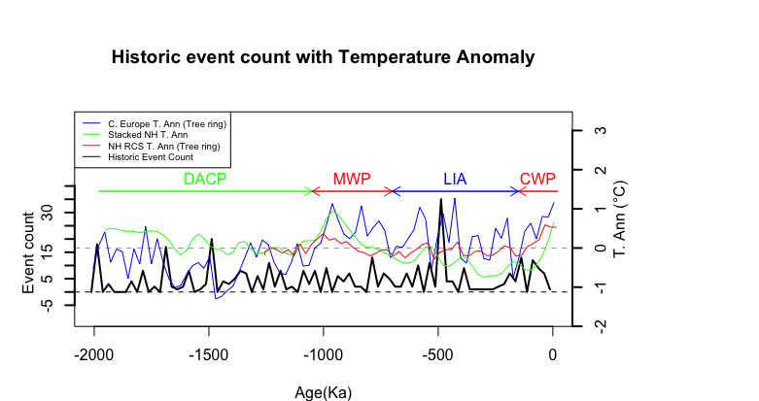

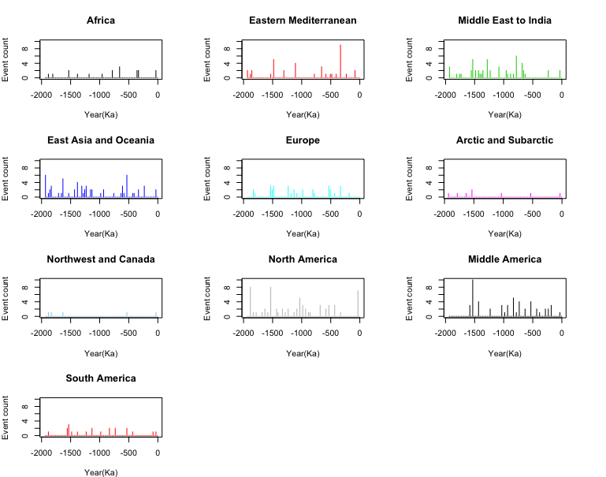

**References:**

1. Zhang, D. D. *et al.* The causality analysis of climate change and large-scale human crisis. *Proc. Natl. Acad. Sci.* **108,** 17296–17301 (2011).
2. B. Peter and B. Peter (2016), “Cultural Responses to Climate Change during the Late Holocene Linked references are available on JSTOR for this article : Cultural Responses to Climate Change During the Late Holocene,” vol. 292, no. 5517, pp. 667–673, 2016.
3. Zheng, J. *et al.* How climate change impacted the collapse of the Ming dynasty. *Clim. Change* **127,** 169–182 (2014).
4. Ge, Q., Hao, Z., Zheng, J. & Shao, X. Temperature changes over the past 2000 yr in China and comparison with the Northern Hemisphere. *Clim. Past* **9,** 1153–1160 (2013).
5. Zhang, D. D. *et al.* The pulse of imperial China: A quantitative analysis of long-term geopolitical and climatic cycles. *Glob. Ecol. Biogeogr.* **24,** 87–96 (2015).
6. DeEr, Z., Hong-Chun, L., Teh-Lung, K. & LongHua, L. On linking climate to Chinese dynastic change: Spatial and temporal variations of monsoonal rain. **55,** 77–83 (2010).
7. Lee, H. F. *et al.* Climate change and epidemics in Chinese history: A multi-scalar analysis. *Soc. Sci. Med.* **174,** 53–63 (2017).
8. Mauri, A., Davis, B. A. S., Collins, P. M. & Kaplan, J. O. The climate of Europe during the Holocene: A gridded pollen-based reconstruction and its multi-proxy evaluation. *Quat. Sci. Rev.* **112,** 109–127 (2015).
9. Gerald H. Haug et al, Climate and the Collapse of Maya Civilization. *Ethnohistory* **42,** 164 (1995).
10. Cullen, H. M. *et al.* Climate change and the collapse of the Akkadian empire: evidence from the deep sea. Geology 28, 379 Á / 82. *Geology;* **28,** 379–382 (2000).
11. Holocene climate and cultural evolution in late prehistoric–early historic West Asia. *Quat. Res.* **66,** 372–387 (2006).
12. Saarni, S., Muschitiello, F., Weege, S., Brauer, A. & Saarinen, T. A late Holocene record of solar-forced atmospheric blocking variability over Northern Europe inferred from varved lake sediments of Lake Kuninkaisenlampi. *Quat. Sci. Rev.* **154,** 100–110 (2016).
13. Hsiang, S. Climate Econometrics. (2016). doi:10.1146/annurev-resource-100815-095343
14. Buhaug, H., Benjaminsen, T. A. & Sjaastad, E. Environmental changes and violent conflict. *Environ. Res. Lett* **7,** 15601 (2012).
15. Koubi, V., Bernauer, T., Kalbhenn, A. & Spilker, G. Climate variability, economic growth, and civil conflict. doi:10.1177/0022343311427173
16. Buhaug, Halvard (2010) Climate not to blame for African civil wars. PNAS 106(49): 20670–20674.
17. Buhaug, H., Benjaminsen, T. A. & Sjaastad, E. Environmental changes and violent conflict. *Environ. Res. Lett* **7,** 15601 (2012).
18. Buhaug, Halvard; Åshild Falch&Nils Petter Gleditsch (2010) The bottom billion and climate change. Paper presented to the 51st Annual Convention of the International Studies Association, New Orleans, LA, 17–20 February.
19. Buhaug, Halvard; Nils Petter Gleditsch & Ole Magnus Theisen (2010) Implications of climate change for armed conflict. In: Robin Mearns & Andy Norton (eds) *Social*

*Dimensions of Climate Change: Equity and Vulnerability in a Warming World*. New Frontiers of Social Policy. Washing- ton, DC: World Bank, 75–101.

1. Burke, Marshall B; Edward Miguel, Shanker Satyanath, John A Dykema & David B Lobell (2009) Warming increases the risk of civil war in Africa. PNAS 106(49): 20670–20674.
2. Chassang, Sylvain & Gerard Padro-i-Miquel (2010) Eco- nomic shocks and civil war. Quarterly Journal of Political Science 4(3): 211–228.
3. Ciccone, Antonio (2011) Economic shocks and civil conflict: A comment. American Economic Review: Applied Economics 3(4): 215–227.
4. Deschenes, Oliver & Michael Greenstone (2007) The economic impacts of climate change: Evidence from agricultural output and random fluctuations in weather. American Economic Review 97(2): 354–385.
5. Devitt, Conor & Richard S J Tol (2012) Civil war, climate change, and development: A scenario study for sub-Saharan Africa. Journal of Peace Research 49(1): 129–145.
6. Garfinkel, Michelle R & Stergios Skaperdas (2007) Economics of conflict: An overview. In: Todd Sandler & Keith Hartley (eds) Handbook of Defense Economics. Amsterdam: Elsevier Science, 649–710.
7. Gleditsch, Nils Petter (1998) Armed conflict and the environment: A critique of the literature. Journal of Peace Research 35(3): 363–380.
8. Hegre, Håvard & Nicholas Sambanis (2006) Sensitivity analysis of the empirical literature on civil war onset. Jour- nal of Conflict Resolution 50(4): 508–535.
9. Hendrix, Cullen & Idean Salehyan (2012) Climate change, rainfall, and social conflict in Africa. Journal of Peace Research 49(1): 35–50.
10. Homer-Dixon, Thomas F (1999) Environment, Scarcity, Violence. Princeton, NJ: Princeton University Press.
11. IPCC (2001) Climate Change 2001: Synthesis Report. Third Assessment Report (AR3) (http://www.grida.no/publica- tions/other/ipcc\_tar/).
12. IPCC (2007) Climate Change 2007: Synthesis Report. Fourth Assessment Report (AR4) (http://www.ipcc.ch/publications\_ and\_data/publications\_ipcc\_fourth\_assessment\_report\_ synthesis\_report.htm).
13. IPCC (2010) Statement on the melting of Himalayan glaciers (http://www.ipcc-wg2.gov/publications/AR4/himalaya-s- tatement-20january2010.pdf).
14. Obama II, Barack Hussein (2009) Climate change speech at the UN General Assembly, 23 September (http://www.nytimes. com/2009/09/23/us/politics/23obama.text.html).
15. Salehyan, Idean (2008) From climate change to conflict? No consensus yet. Journal of Peace Research 45(3): 315–326.
16. Sambanis, Nicholas (2001) Do ethnic and nonethnic civil wars have the same causes? A theoretical and empirical inquiry (Part 1). Journal of Conflict Resolution 45(3): 259–282.
17. WBGU (2008) Climate Change as a Security Risk. London: Earthscan.
18. Zhang, David D; Peter Brecke, Harry F Lee, Yuan-Qing He& Jane Zhang (2007) Global climate change, war, and popu- lation decline in recent human history. PNAS 104(49): 19214–19219.
19. Theisen, O. M., Gleditsch, N. P. & Buhaug, H. Is climate change a driver of armed conflict? *Climatic Change* **117,** 613–625 (2013).
20. Hsiang, S. M., Meng, K. C. & Cane, M. A. Civil conflicts are associated with the global climate. *Nature* **476,** (2011).
21. Snyder, Jack&Robert Jervis (1999) Civil war and the security dilemma. In: Barbara Walter & Jack Snyder (eds) Civil War, Insecurity and Intervention. New York: Columbia Uni- versity, 15–37
22. Zhang, David D; Peter Brecke, Harry F Lee, Yuan-Qing He& Jane Zhang (2007) Global climate change, war, and popu- lation decline in recent human history. PNAS 104(49): 19214–19219.
23. Li, J. *et al.* Chinese Dynasty - Quantifying climatic variability in monsoonal northern China over the last 2200 years and its role in driving Chinese dynastic changes. *Quat. Sci. Rev.* **159,** 35–46 (2017).

**Materials and methods**

Fourier spectral analysis

Periodogram,

Multitaper analysis

Evolutive harmonic analysis

--- > Significant periodicity, cyclicity

Correlation

Causality

Granger causality, convergent cross mapping, vector autoregression

**Data**:

Frequency of Events in the last 2000 years.

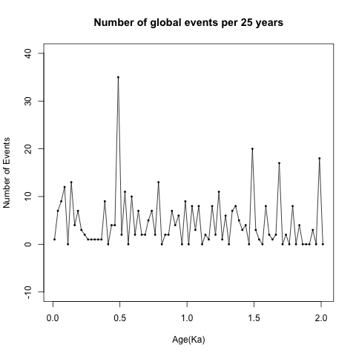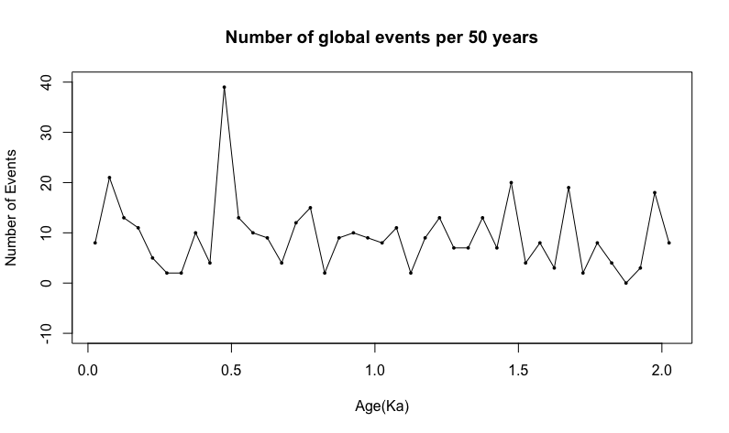

Frequency of Events in the last 5000 years and then for the whole Holocene epoch. But events are clustered in the nearest thousands like (3Ka, 4Ka, 5Ka) which are misleading.

Analysis on the event frequency data from last 2000 years.

Data Processing: Convert the non-stationary event number time series to a weak stationary time series(mean and autocovariance does not change with time) to further do cycle analysis.

1. Demean
2. Filtering with Hanning moving average
3. Detrending (residuals from linear regression)
4. Tapering
5. Hanning smoothing of power spectra

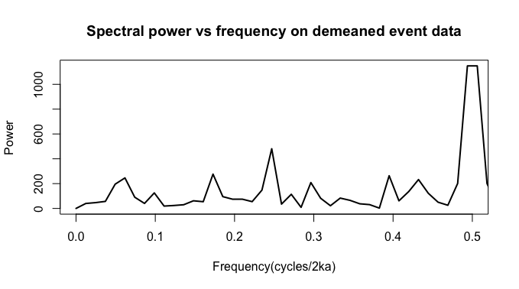

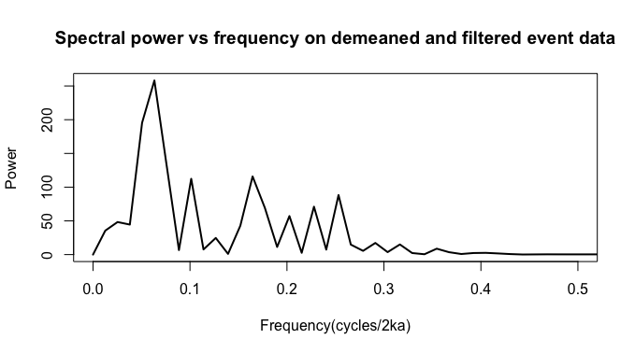

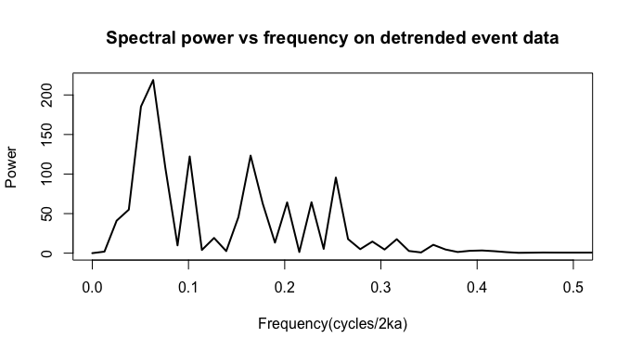

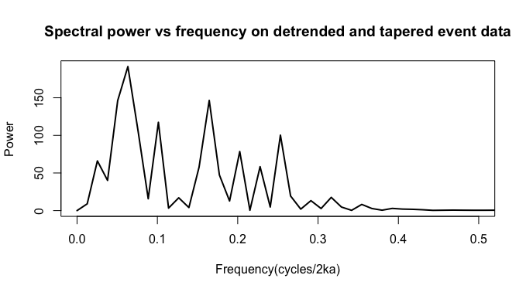

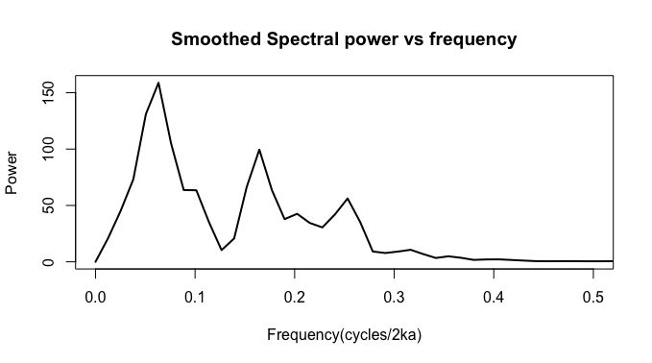

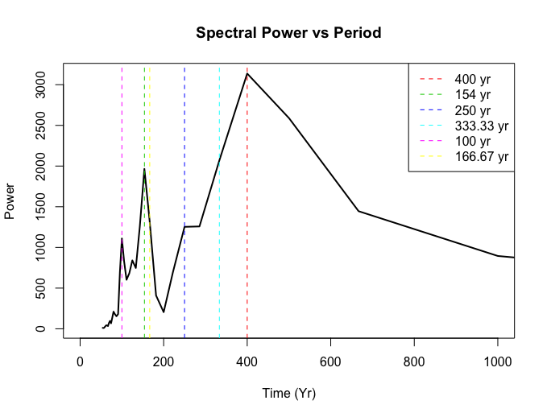

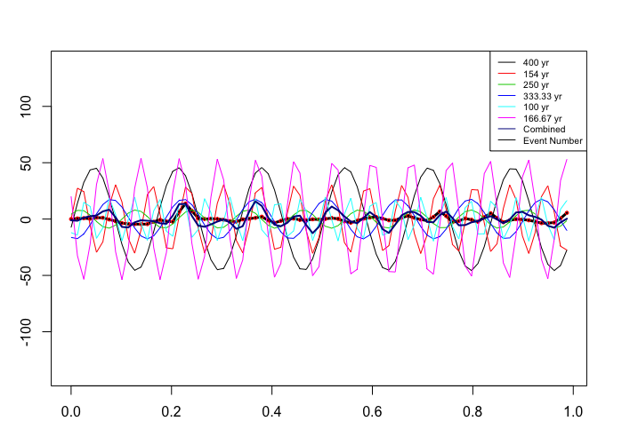

|  |  |  |  |  |
| --- | --- | --- | --- | --- |
| **# Cycles** | **Frequency** | **Period** | **Amplitude** | **Power** |
| 6 | 0.06329114 | 400.0000 | 122.99625 | 158.83075 |
| 14 | 0.16455696 | 153.8462 | 107.57012 | 99.50760 |
| 5 | 0.05063291 | 500.0000 | 107.54739 | 131.11470 |
| 9 | 0.10126582 | 250.0000 | 96.29151 | 63.44699 |
| 7 | 0.07594937 | 333.3333 | 91.47636 | 104.76960 |
| 21 | 0.25316456 | 100.0000 | 89.00611 | 56.19316 |
| 17 | 0.20253165 | 125.0000 | 78.75561 | 42.57242 |
| 3 | 0.02531646 | 1000.0000 | 72.24159 | 45.31505 |
| 19 | 0.22784810 | 111.1111 | 67.90576 | 30.50830 |
| 13 | 0.15189873 | 166.6667 | 67.54380 | 66.50646 |

The top 10 frequency and periods shown in the event frequency data.

|  |  |  |  |
| --- | --- | --- | --- |
| **# Cycles** | **Frequency** | **Power** | **Period** |
| 5 | 0.0625 | 45.40252 | 405.0633 |
| 4 | 0.05 | 35.09184 | 506.3291 |
| 14 | 0.175 | 31.08893 | 144.6655 |
| 8 | 0.1 | 29.57111 | 253.1646 |
| 20 | 0.25 | 27.1028 | 101.2658 |
| 6 | 0.075 | 24.99689 | 337.5527 |
| 2 | 0.025 | 21.18668 | 1012.6582 |
| 18 | 0.225 | 19.44715 | 112.5176 |
| 13 | 0.1625 | 17.98304 | 155.7936 |
| 12 | 0.15 | 12.357 | 168.7764 |

Using periodogram of R (spec.pgram) gives pretty close answer. Power values are different due to normalization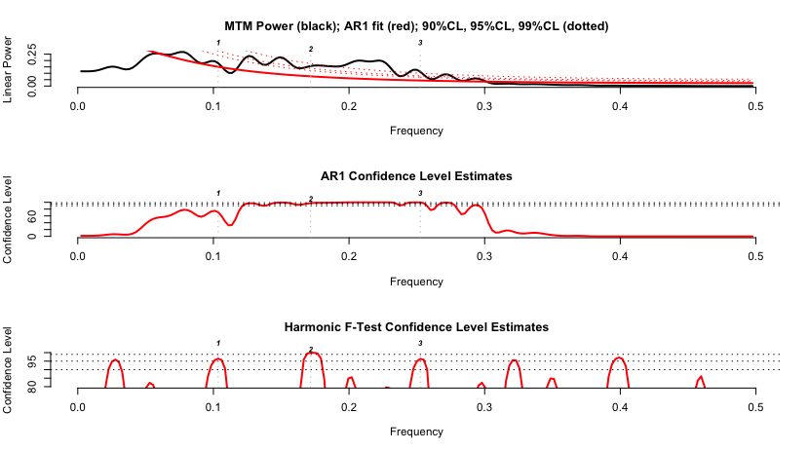

Frequency Harmonic\_CL period

2 0.0625000 0.9803090 405.0633

4 0.1679688 0.9899981 150.7212

5 0.2500000 0.9685964 101.2658

Evolutive Harmonic Analysis



Northern Hemisphere Temperature Data

Christiansen and Ljungqvist [52]: stack of different temperature proxies [°C], extracted from 91 single records, ~30% of them covering the total period, 0 to 1973 AD, 1 year time resolution, northern hemisphere.

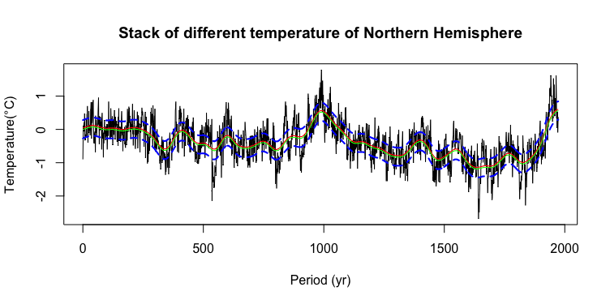

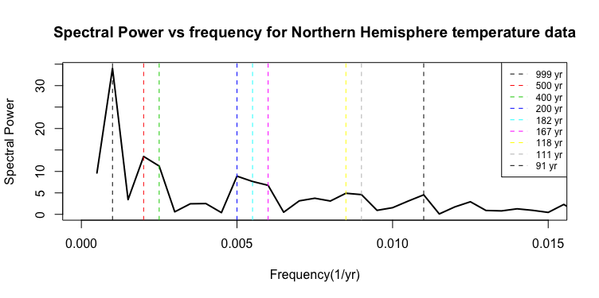

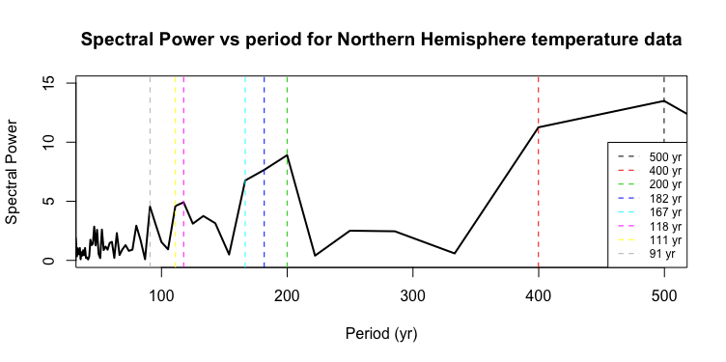

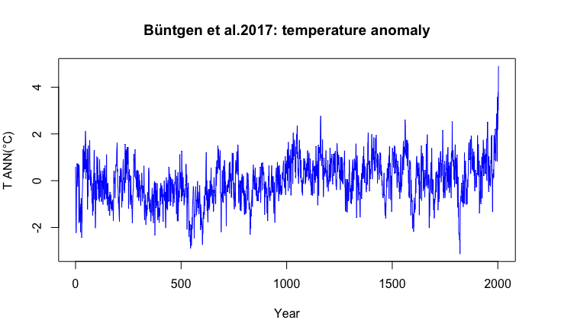

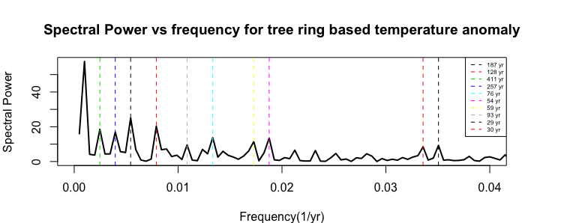

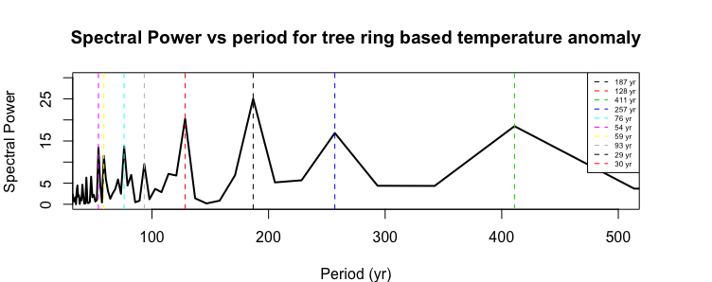

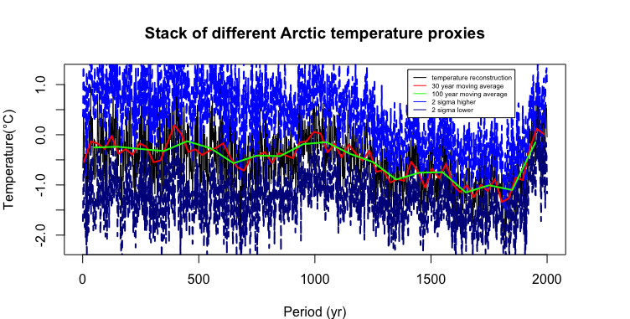

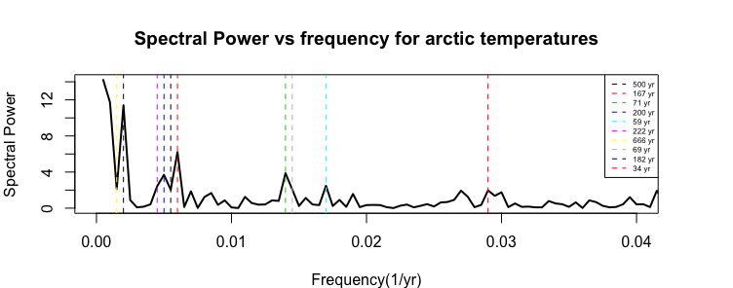

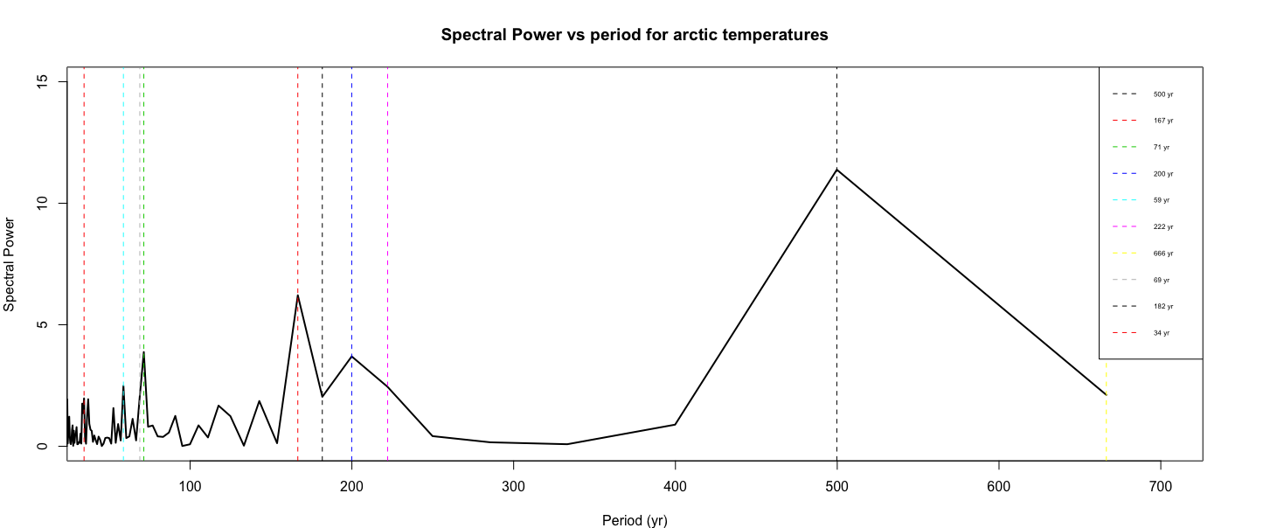

Events in Africa during last 2 thousand years.



Events in the region of East Asia and Oceania during last 2 thousand years.

tscreator_output/Global_event_numbers_50_yr_bin_East_Asia_Oceania_from_0_to2ka.pdf

Events in Middle eastern and Indian region during last 2 thousand years. However, the Indian region events are missing many details of the history of Indian subcontinent.

tscreator_output/Global_event_numbers_50_yr_bin_Middle_East_India_from_0_to2ka.pdf

Events in the region of East Asia and Oceania during last 2 thousand years.

**tscreator_output/Global_event_numbers_50_yr_bin_East_Asia_Oceania_from_0_to2ka.pdf**

Events in European region during last 2 thousand years.

tscreator_output/Global_event_numbers_50_yr_bin_Eastern_Mediterranean_from_0_to2ka.pdf

**Left**: Events in Arctic and Sub-arctic regions during last 2 thousand years. **Right**: Events in Northwest and Canada during last 2 thousand years.

tscreator_output/Global_event_numbers_50_yr_bin_Arctic_Subarctic_from_0_to2ka.pdf tscreator_output/Global_event_numbers_50_yr_bin_Northwest_Canada_from_0_to2ka.pdf

Events in North American region during last 2 thousand years.

tscreator_output/Global_event_numbers_50_yr_bin_North_America_from_0_to2ka.pdf

Events in Middle and South American region during last 2 thousand years.

tscreator_output/Global_event_numbers_50_yr_bin_Middle_South_America_from_0_to2ka.pdf

**Reference:**

1. Christiansen B, Ljungqvist FC. The extra-tropical Northern Hemisphere temperature in the last two millennia: reconstructions of low- frequency variability. Clim Past 2012; 8: 765-786. Data available at ftp://ftp.ncdc.noaa.gov/pub/data/paleo/contributions\_by\_author/ christiansen2012/christiansen2012.txt 2017. (last access: April).
2. Büntgen U, Tegel W, Nicolussi K, et al. 2500 years of European climate variability and human susceptibility. Science 2011; 331: 578-582. Data available at ftp://ftp.ncdc.noaa.gov/pub/data/paleo/treering/reconstructions/europe/buentgen2011europe.txt. 2017. (last access: April)
3. McKay NP, Kaufmann DS. An extended Arctic proxy temperature database for the past 2,000 years. Sci Data 2014; 1(140026). Data available at http://ncdc.noaa.gov/paleo/study/16973 2017. (last access: April).
4. Villalba R, Boninsegna JA, Masiokas M, et al. Large-Scale Temperature Changes Across the Southern Andes: 20th -Century Variations in the context of the Past 400 Years. Climatic Change 2003; 59: 177-232. Data available at: ftp://ftp.ncdc.noaa.gov/pub/data/paleo/treering/ reconstructions/southamerica/patagonia-temperature.txt 2017. (last access: April).
5. Kantelhardt JW, Koscielny-Bunde E, Rego HH, Havlin S, Bunde A. Detecting long-range correlations with detrended fluctuation analysis. Physica A 2001; 295: 441-54. [http://dx.doi.org/10.1016/S0378-4371(01)00144-3]